FAIL SAFE
Pictorial representation of Fail Safe to understand:
Note: please check my previous post on Time Travel to understand better (snowflake_31)
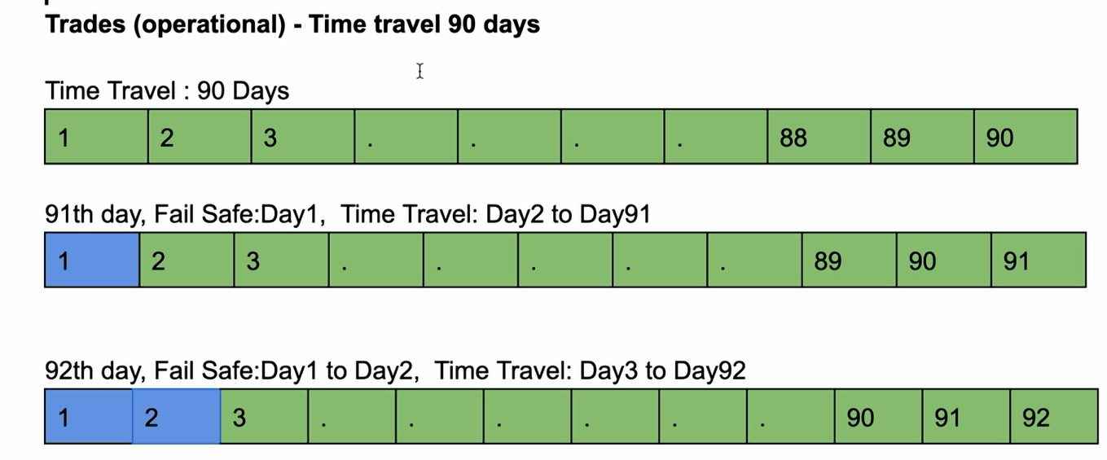

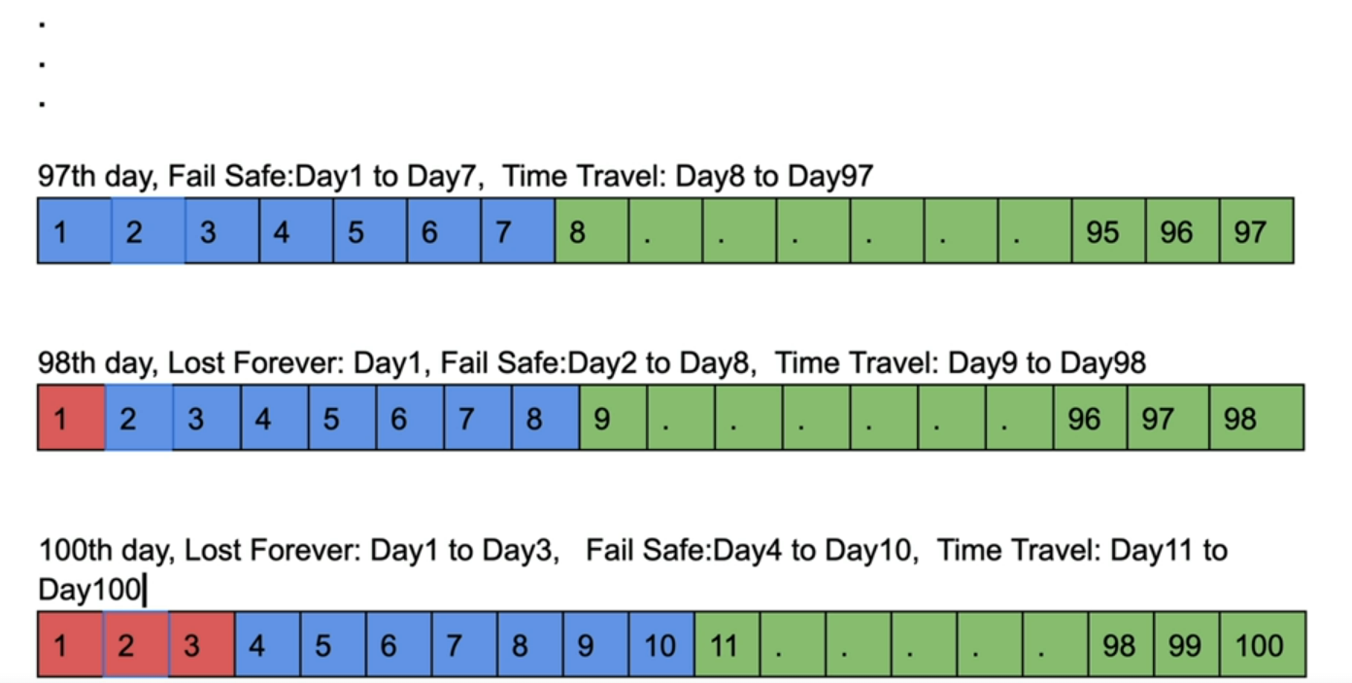
Example2:
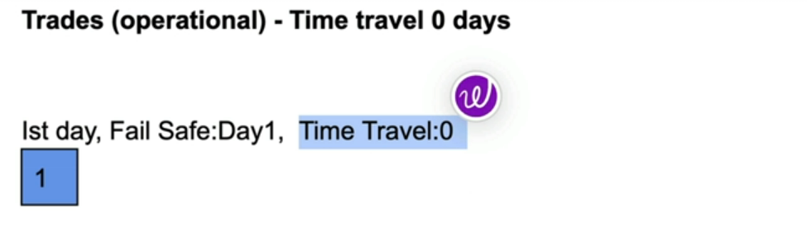
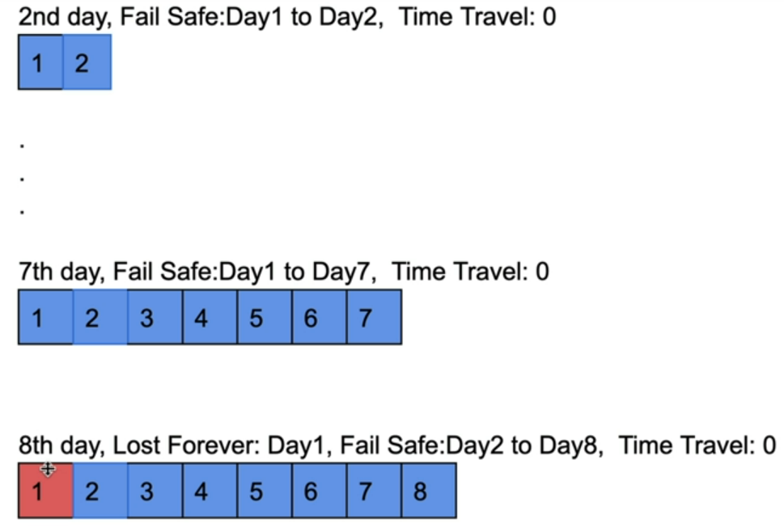

You can check Fail Safe storage bytes in snowflake UI as shown
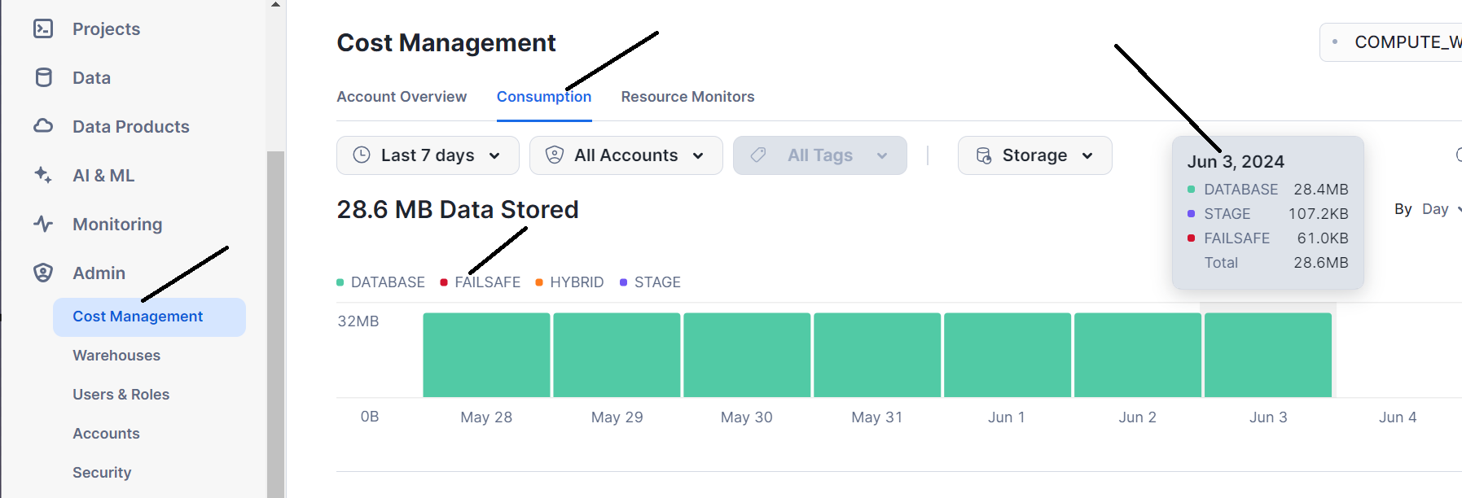
You can check by query as shown with respect to usage date
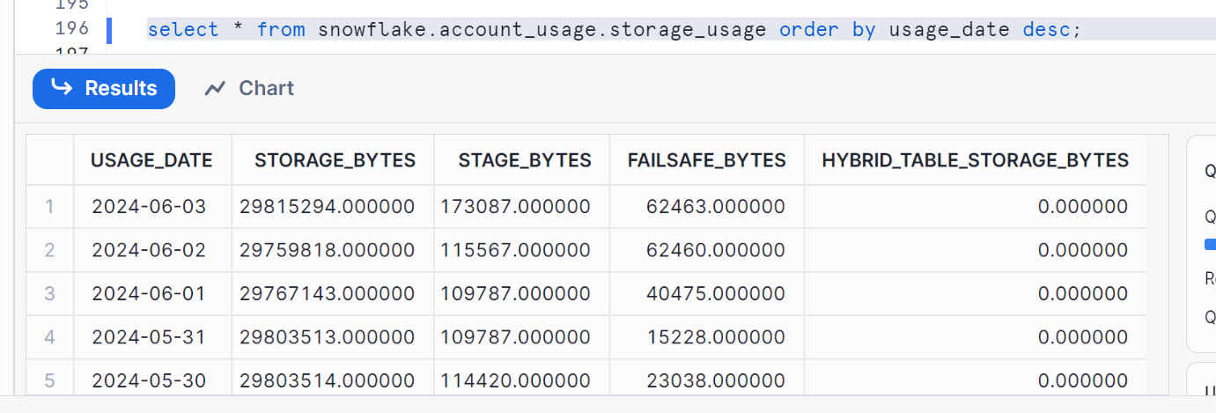
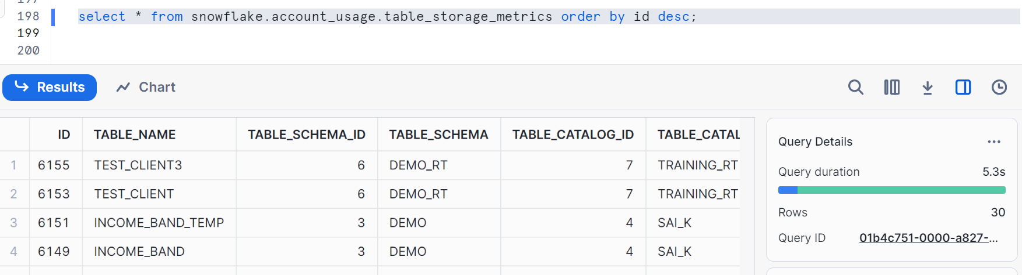

Some important points in FAIL SAFE:
